Student Name
Teacher


Assessment task

Psychology –

GENERAL Year 11

Task 1 – Unit 1
Assessment type: Investigation- Data Interpretation

Conditions

Time allowed for completion of the task: 55 minutes

Task weighting

10% of Unit 1

To be provided by the supervisor:
This Question/answer booklet

To be provided by the candidate

Standard items: Pens, pencils, eraser or correction fluid, ruler, highlighter

Special items: Non-programmable scientific calculator

Structure of this paper

Section | Number of questions available | Suggested working time  (minutes) | Your Mark | Marks available | Percentage
Section One:  Short Answer | 6 | 55 |  | 42
 |  | Total |  | 42 | /100

Important note to candidates

No other items may be used in this test. It is your responsibility to ensure that you do not have any unauthorised notes or other items of a non-personal nature in the test room. If you have any unauthorised material with you, hand it to the supervisor before reading any further.

Data Interpretation

- Dr Stevens conducted a study with a group of Psychology students to determine the relationship between the numbers of hours spent studying Psychology per week and the final examination score. The results of this study are shown in the table below.
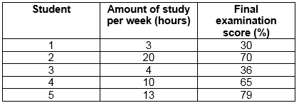

  - State the median examination score from this group. 65%
(1 mark)
  - Calculate the mean number of hours studied by this group. 10 hours
(1 mark)
  - Calculate the range of examination scores from this group. 49
(1 mark)

  - Plot a scattergram of these scores on the axes provided. Label the scattergram appropriately.
(5 marks)
Description | Marks
One mark to be allocated to each of the following points:  • Horizontal axis labelled with units (either variable as they are behavioural) (1 mark)  • Vertical axis labelled with units (1 mark)  • Correct title (Relationship between the numbers of hours spent studying Psychology per week and the final examination score.) (1 mark)  • Use of dots (not a line graph) (1 mark)  • Correct graphing of all data from the table (1 mark) | 1  1  1  1  1
Total | 5

- Researchers are designing an experiment to determine whether listening to music while exercising causes people to exercise harder. There will be 100 participants in the experiment, 50 in the experimental group, and 50 in the control group.

  - List two variables that should be controlled in this experiment.
One: Type of music
Two: Length of exercising etc.
(2 marks)
  - Identify one ethical consideration relevant to this study. Explain how the researchers would deal with this consideration in their research.
Description | Marks
1 mark for ethical consideration and 1 mark for appropriate action.  Informed consent/ Underage participants: guardians receive information and sign to agree to participation.  Withdrawal rights: can leave study any time without ramifications/ pressure  Confidentiality: share no personal details  Voluntary participation: Do not coerce participants; compensation to be commensurate. | 0-2
Total | 2
(2 marks)
- The coach at a local under 18’s soccer team is concerned over the number of players that are missing games due to illness. He decides to investigate whether vitamins would decrease the amount of colds his team is experiencing.

  - Identify the independent variable and the dependent variable.
Independent: Type or amount of vitamins (1)
Dependent: Number of games played (1)
(2 marks)
  - Identify two variables he can control.
Description | Marks
Responses include but are not limited to:  Participant: age; vitamin type; vitamin quantity  Situational: winter season | 0-2
Total | 2
(2 marks)
  - Identify two variables he cannot control.
Description | Marks
Responses include but are not limited to:  Participant variables: susceptibility to illness; other medication taken; tolerance to vitamins  Situational variables: weather; other activities the individual is involved in | 0-2
Total | 2
(2 marks)
  - Name and explain one ethical consideration the coach needs to follow and include how he can achieve this.
Description | Marks
Informed consent (1). Participants are informed of the true nature of the investigation and any possible risk associated with participation (1). Each participant will receive a letter of informed consent outlining the nature of the investigation and any possible risk. They will be required to sign the informed consent. As they are under the age of 18 their parents will also need to sign the consent form (1).  Voluntary participation (1). All participants are willing to be included in the investigation (1). Participants give their consent (1).  Withdrawal rights (1). Participants have the right to withdraw at any stage of the investigation without receiving any negative consequences (1). Participants are notified within their informed consent that they can withdraw at any stage (1).  Confidentiality (1). Participants details are kept confidential (1). Participants will be given a number which will be used to identify them. All data will be shredded at the completion of the investigation (1). | 0-3
Total | 3
(3 marks)
- A psychologist collected data on the self-esteem of ten young people who were currently involved in volunteer work in their community, using a Likert scale.
The Likert scale produced scores for each person ranging from 10 to 50. Higher scores indicated higher levels of self-esteem.

The self-esteem scores for the 10 young people were:
30, 32, 38, 40, 45, 43, 46, 38, 45, 46

  - Complete the frequency table below.
(1 mark)
Self-esteem score | Number of people | Description | Marks
11–15 | 0 | All correct. | 0-1
16–20 | 0 | Total | 1
21–25 | 0
26–30 | 1
31–35 | 1
36–40 | 3
41–45 | 3
46–50 | 2
Total | 10

  - The psychologist is writing a report on the results of the research and needs to include a graph of the frequency of self-esteem scores. Graph the results from the frequency table in question 4 a) on the axes below.
(4 marks)
Description | Marks
One mark to be allocated to each of the following points:  • Horizontal axis correctly labelled (self-esteem score) (1 mark)  • Vertical axis to be correctly labelled (number of students or frequency) (1 mark)  • Use of a column / bar graph (not a line graph) (1 mark)  • Correct graphing of all data from the table (1 mark) | 1  1  1  1
Total | 4
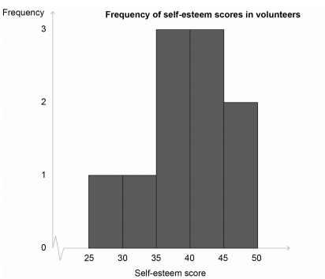
- Dr Warr was interested in the effects of social media on teens. He asked his friend Ayla if he could use her four adolescent children in his study and follow their use of social media. Ayla agreed that her 13-year-old twins Shae and Nyah, her 15-year-old son Zion, and her 18-year-old son Zhaun could be a part of Dr Warr’s study.

  - Ayla was not the only one who needed to give permission for her children to be a part of Dr Warr’s study. Identify another individual who needed to give consent and explain why they also needed to give consent.
Description | Marks
Zhaun (1). He is legally considered an adult and therefore needs to give his own consent (1). | 1  1
Total | 2
(2 marks)
  - Dr Warr continued to follow the social media use of Ayla’s children for the next five years. At which time Zion finished school and decided to move overseas to go to university. He told Dr Warr that he would no longer be participating in his study. Name the ethical right he followed.
Description | Marks
Withdrawal right. | 0-1
Total | 1
(1 mark)

The table below represents some of the data Dr Warr collected on Ayla’s children in 2011.
 | Facebook | Instagram | Snapchat | Twitter
Nyah | 1555 | 460 | 856 | 29
Shae | 1200 | 980 | 320 | 26
Zion | 765 | 460 | 10 | 49
Zhaun | 205 | 6 | 2 | 31
Table 1: Number of hours spent in 2011 on various forms of social media

  - Calculate the mean amount of time Ayla’s children spent on Facebook in 2011.
931.25 hours
(1 mark)
  - Identify the range for the amount of time the siblings spent on Snapchat.
854 hours
(1 mark)
  - Identify which sibling, on average across the various forms of social media spent the most time on social media in 2011. Record the amount of time they spent.
Nyah (1) on avg. 725 hours (1)
(2 marks)
- Macy was interested in studying the relationship between age and weight. She collected data from a range of people and created the following graph. However, she forgot to label the axis and give the graph a title.
  - Complete Macy’s graph by giving it and appropriate title in the correct place and labelling the X and Y axis.
(4 mark)

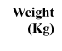
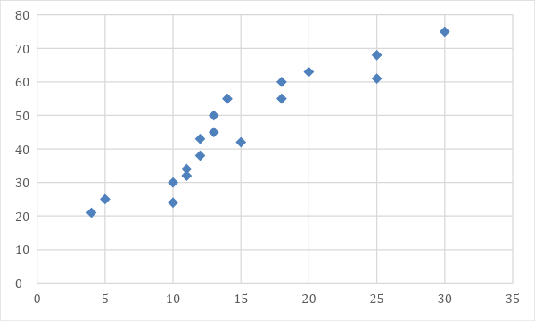

Age (years)
Figure 1: Relationship between weight and age

Description | Marks
Scatter Appropriate title (1) and correct positioning of the title (1)  Y axis – Weight (kg) (1)  X axis – Age (years) (1)  Note: The measurement is needed for both axes. | 0-4
Total | 4

  - What type of graph did Macy create?
Description | Marks
Scatter graph / scatter plot / scattergram (1) | 0-1
Total | 1
(1 mark)
  - Provide a possible hypothesis for Macy’s research.
Description | Marks
It is hypothesised that as age increases so too does a person’s weight.  1 mark for including both variables  1 mark for writing hypothesis as a prediction. | 1  1
Total | 2
(2 marks)

  - Explain how Macy will ensure the ethical consideration of informed consent will be met in this investigation.
Description | Marks
Give participants written information regarding (any 1 of the following for 1 mark)  - their rights  - true purpose of the study  - possible physical/psychological harm  - outline their withdrawal rights  - research procedures used  Get permission from parents if under 18 (1 mark) | 1  1
Total | 2
(2 marks)
END OF TEST

